**Python Data Types**

* float - int - str - bool (True, False)
* type() function displays the type of a value
* 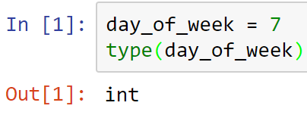
* 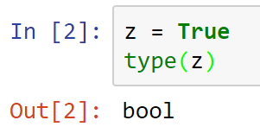

**Operator overloaded**

* The operators behave differently for different types
* Below plus means add
* 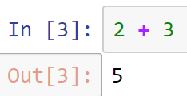
* While the plus below means concatenate
* Note that print() function is optional
* 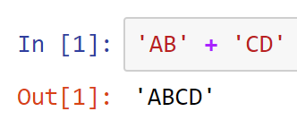

**Printing**

* Printing Python style
* 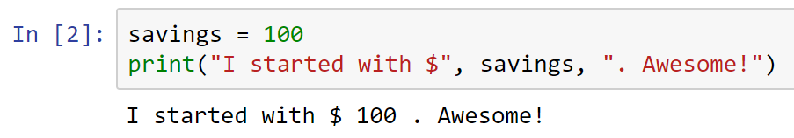

**str()**

* Printing Java style
* Note also below the use of str() function to convert numbers to text
* 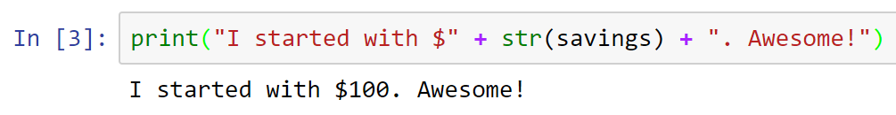

**Casting and type()**

* Converting string to float and checking the type
* 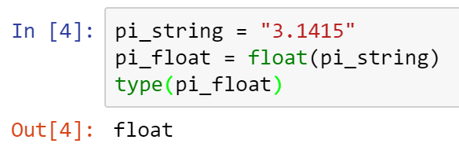

**max()**

* 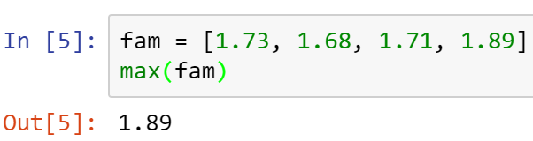

**round()**

* 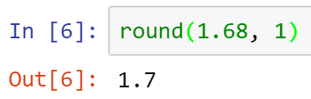

**Help built-in**

* 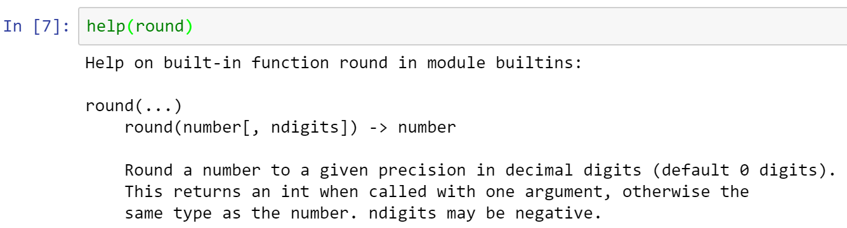

**index()**

* Python can return the index given a value
* 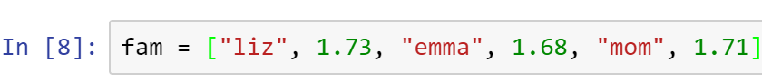
* 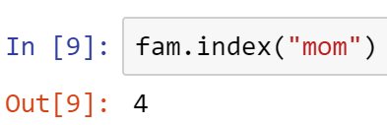

**count()**

* Python can also count an elements in the list
* 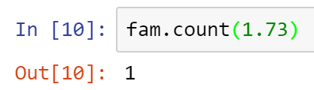

**String methods**

**capitalize()**

* 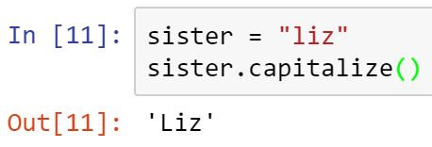

**replace()**

* 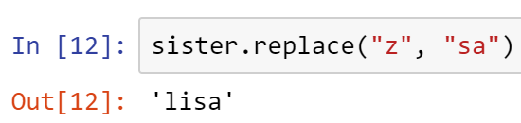

**append()**

* 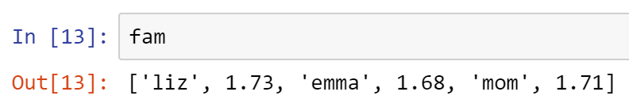
* 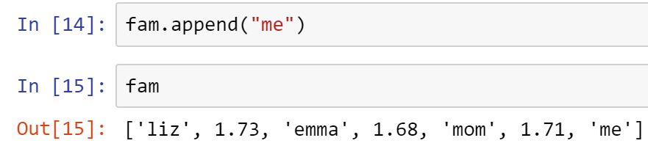
* Copy all your code into a Word doc, place your name on it, and submit in Canvas.